Title Goes Here: First Letter of Each Word Should Be Capitalized Except for Articles, Prepositions, and Conjunctions

Richard K. Smith1*, Taro Suzuki2, and Hiro Satoh2,3

1Department of Physics, Cavendish Laboratory, University of Cambridge, Cambridge CB3 0HE, U.K.

2National Institute for Materials Science, Tsukuba, Ibaraki 305-0047, Japan

3Institute of Materials Research, Tohoku University, Sendai 980-8577, Japan

E-mail: xxxxx

(Received Month dd, year)

Abstract should state briefly (roughly up to 100 words) the general aspects of the subject and the main conclusions. It should not contain display equations. It is not part of the text and should be complete in itself: no table numbers, figure numbers, or references should be given. It must be a single paragraph.

1. Introduction

The Japan Society of Applied Physics (JSA) has launched a conference proceedings series, *JJAP Conference Proceeding*. This is a fully Open Access publication so that anybody can view the full-text PDF file of each article for free-of-charge.

2. Tables and Figures

*2.1 Format*

This template is compatible with both A4- and Letter-size paper. Therefore, please do not change any margin of this file. The editorial office will insert a heading for each article so please do not add a heading.

2.2 Main text

Main text should be started with Introduction. Footnotes can be made only for author's present addresses. Any literature, comments, or remarks should be listed in references [1,2,3]. Physical quantities must be typed in italic. Roman type should be used for the following items: units, chemical symbols, mathematical operators, and log-like functions.

2.3 Tables

**Table I.** The following expressions should be used.

|  |  |
| --- | --- |
| At the beginning of a sentence | Within a sentence |
| Section 1 | Sect. 1 |
| Section 2 and 3 | Sects. 2 and 3 |
|  |  |
| Equation (1) | Eq. (1) |
| Equations (2) and (3) | Eqs. (2) and (3) |
| Equations (4) – (10) | Eqs. (4) – (10) |
|  |  |
| Table I | Table I |
| Tables I and II | Tables I and II |
| Tables II– VI | Tables II– VI |
|  |  |
| Figure 1 | Fig. 1 |
| Figures 1(a) and 1(b) | Figs. 1(a) and 1(b) |
| Figures 2–5 | Figs. 2–5 |
|  |  |
| Reference 1 | Ref. 1 |
| References 1 and 2 | Refs. 1 and 2 |
| References 3–5 | Refs. 3–5 |
|  |  |

2.4 Figures

Figures should be numbered consecutively in Arabic numerals (i.e., 1, 2, 3…). Caption should be typed below the figure.

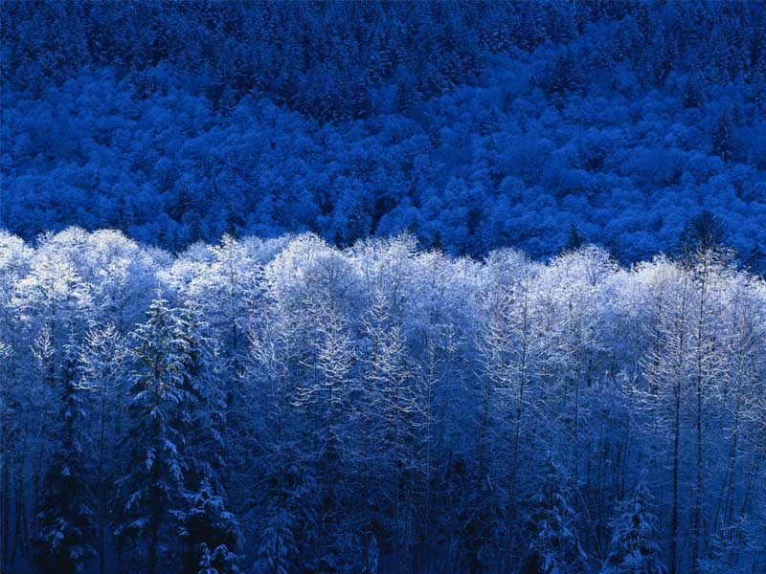

**Fig. 1.** Figures are printed in black and white in the printed version, unless your Conference organizer allows you to use color. Lines in figures should be more than 0.3pt(0.1mm). Thinner lines than 0.3 pt (0.1 mm) may disappear in the printed version.

2.5 Equations

Equations, especially display equations, should be prepared using the Equation Editor if possible.

3. Conclusion

The main text should be ended with Conclusion or Summary.

Acknowledgment

Acknowledgment follows the main text of the paper. No section numbers should be given.

Appendix

If necessary, Appendixes can be written after the acknowledgment. If there are two or more appendixes, they should be labeled Appendix A, Appendix B, etc.

**References**

1. H. Maeda, Y. Tanaka, M. Fukutomi, and T. Asano, Jpn. J. Appl. Phys. **27**, 209 (1988).
2. E. Freedman and G. Yamada, *Plasma Acceleration* (MacGraw-Hill, New York, 1982) 2nd ed., Vol. 1, Chap. 2, p. 70.
3. T. Sawada: Proc. 1987 INS-RIKEN Int. Symp. Heavy and Physics, Tokyo, 1987.
4. Footnotes can be made only for author's present addresses. Any comments or remarks should be listed in references.
5. Each reference number should correspond to one reference. Different papers by the same authors are recommended to be listed separately in the reference list under different number.